**Assignment 1**

1. **[30 points] Project 1**

Figure 7-44 shows the file’s contents displayed in Notepad. Create an application that reads this file’s contents into a List, displays the List’s contents in a ListBox control, and calculates and displays the total, average, max, and min of the values.

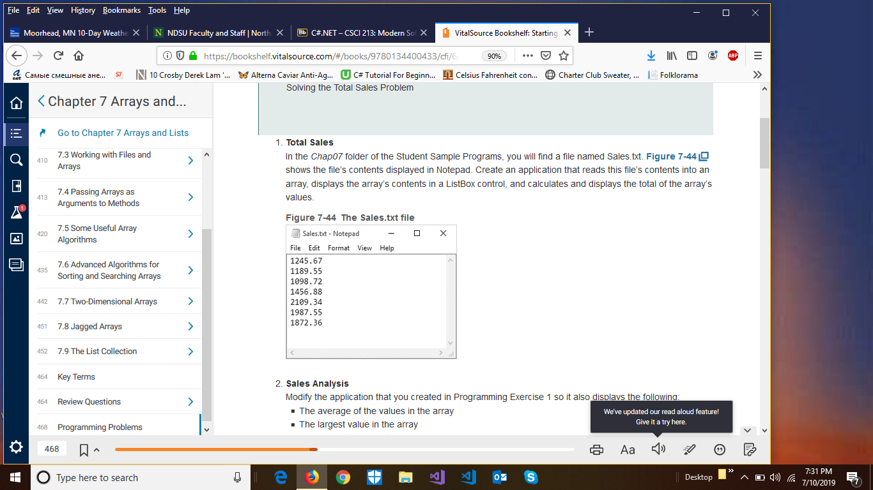

1. **[20 points] Project 2**

Note: Use List data( not an Array) structure.

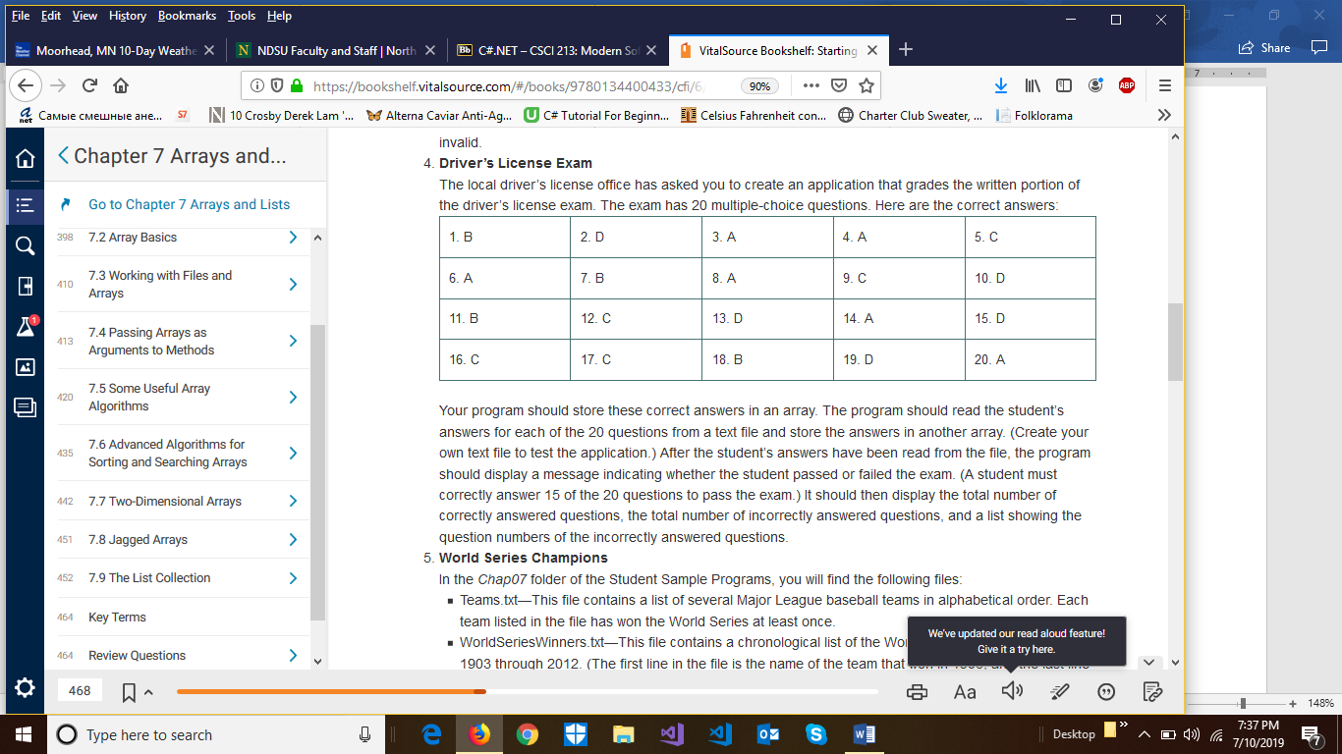

1. **[20 points] Project 3**

